**IR sensing array**

Parts:

(1) DSSC-0107 pre-soldered PCA9547 I2C multiplexer

(4) D6T-8L-06 1x8 pixel IR camera

(4) GHR-04V-S connectors

(16) SSHL-002T-P0.2 connector terminals

(12) 4.7kOhm resistors

Procedure:

Connectors

Crimp SSHL-002T-P0.2 connector terminals around 26AWG wire and solder the wires in place. Place each connector terminal into a slot on the GHR-04V-S connectors (4 connector terminals in each connector). Insert each connector into a D6T-8L-06 camera.

Wiring

Wire the SDA input and SCL input on the I2C mux each to a separate 4.7k resistor and then to a 5V rail. Wire the node between the resistor and the SDA and SCL input on the I2C mux to the SDA and SCL outputs on the board (Figure 1 for Arduino Uno). Wire the SDAx, SCLx, and INT0 lines on the mux (SDA1, SCL1, SDA2, SCL2, etc.) each to separate 4.7k resistors and then to a 5V rail in accordance with the I2C protocol (Figure 2). Wire the node between the resistors and the SDAx and SCLx lines to a set of SDA and SCL lines on the IR cameras (Figure 3).

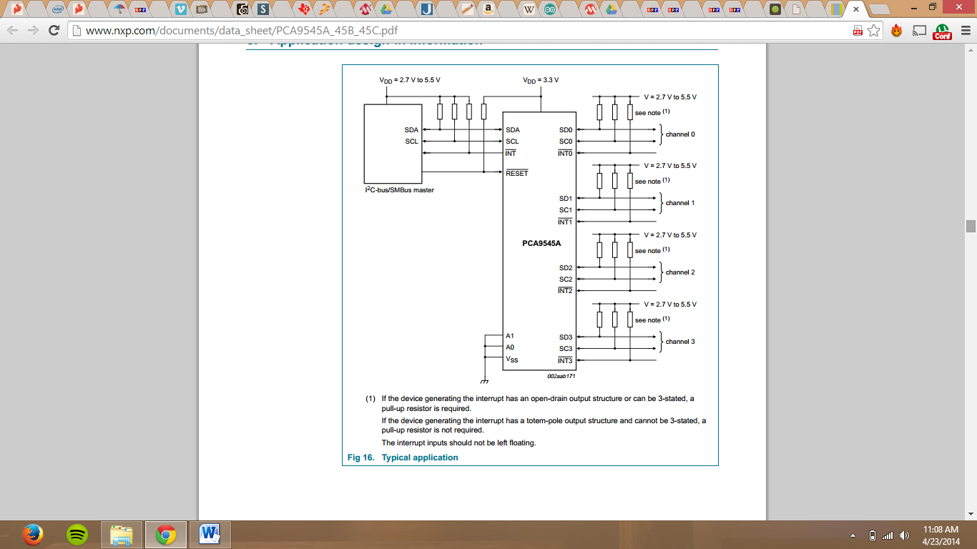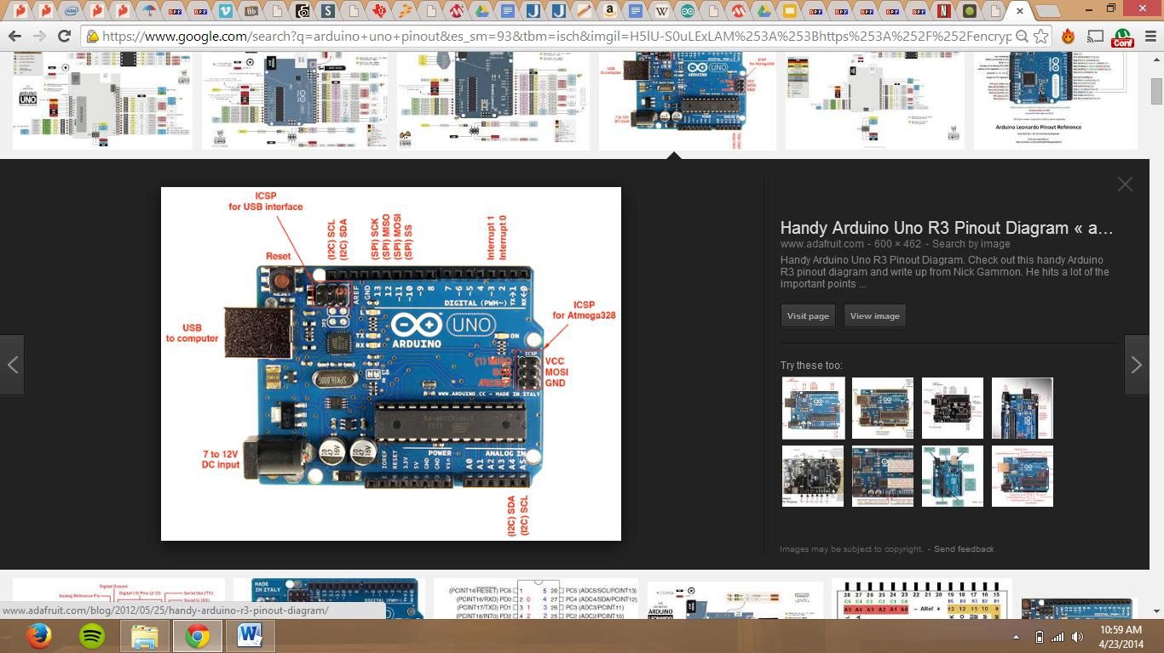

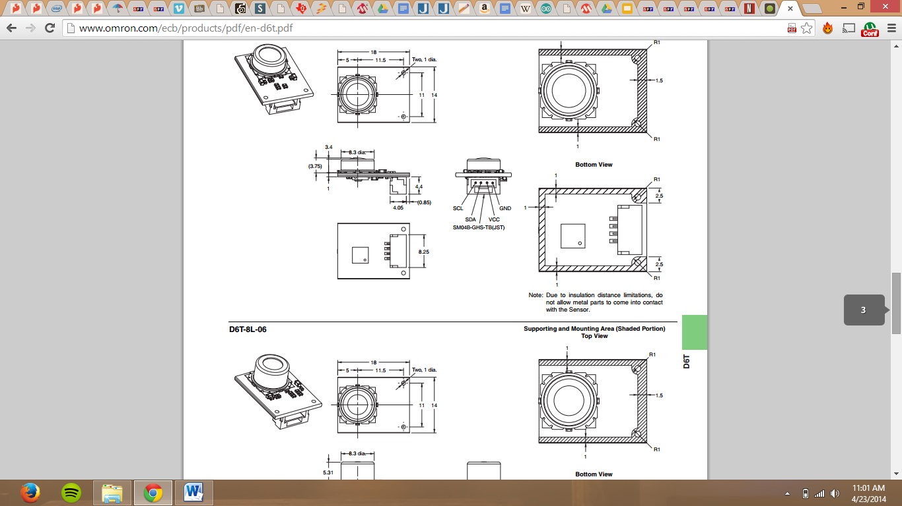Figure 1: Arduino Uno I2C pins

Figure 2: IR camera wiring Figure 3: Complete I2C wiring diagram. I2C master is board and I2C slaves are IR cameras

Programming

In order to properly use the IR camera, first the I2C mux must be addressed and set to the appropriate channel. If more information about the I2C mux and its commands is desired, see the PCA9547 data sheet. The procedure to select channels using the I2C mux according to I2C protocol is below:

1. Start condition
2. Address (B1110000) or write address (B11100000) (Arduino I2C library needs only address)
3. Write command for desired channel
   1. B00000100 – Channel 0
   2. B00000101 – Channel 1
   3. B00000110 – Channel 2
   4. B00000111 – Channel 3
4. Stop condition

Once the channel has been selected, one can then read the IR camera itself. If more information about the IR camera and its commands is desired, see the Omron D6T white papers. The procedure to read each IR camera using the I2C protocol is below:

1. Start
2. Address (0x0a) or write address (0x14) (Arduino I2C library needs only address)
3. Write 0x4C
4. Repeated start condition
5. Address (0x0a) or read address (0x15) (Arduino I2C library needs only address)
6. Read 19 bytes
7. Stop condition

The 19 read bytes are identified in figure 4. PTAT is the ambient temperature. P0 is the topmost pixel and P7 is the bottommost pixel of the IR camera. PEC is the program error code (largely useless).

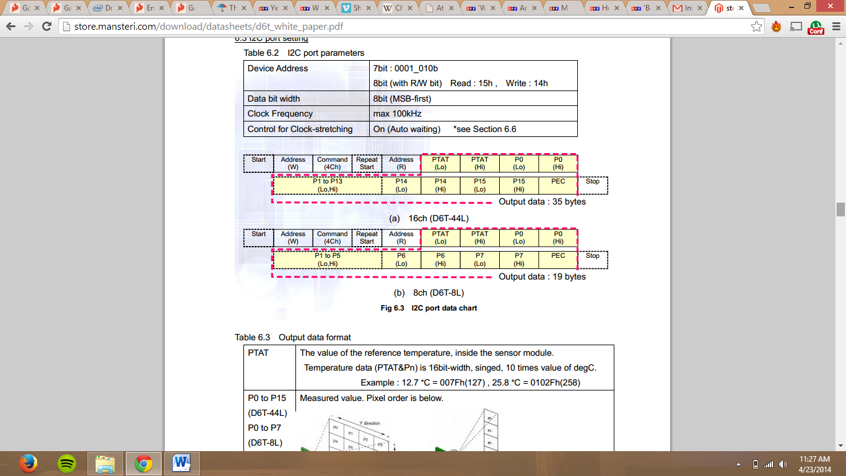

Figure 4 – Reading the IR camera via I2C